EXPERIMENT 3 :- THRESHOLD FREQUENCY = 45

--------------- **RAINFALL NORMALISED | LINEAR KERNEL FUNCTION**  ---------------

|  |  |  |  |
| --- | --- | --- | --- |
| **INPUT** | | **MODEL** | |
| TRAINING SET | CONCATENATED INSTANCES FROM 1 TO 3904, FROM 2 TO 3905 AND FROM 3 TO 3906 OF EXTMAT2 | SUPPORT VECTOR MACHINE REGRESSION MODEL | |
| TARGET FOR THE TRAINING SET | INSTANCES FROM 4 TO 3907 OF rain_mum_1969_2007_1grid_norm | TRAINING | * mdl7_2 = fitrsvm(T4_2,G) * Trained using the predictor values in the matrix T4_2 and the response values in the vector G * T4_2[3904 x 3030]=instances from 1 to 3904, from 2 to 3905 and from 3 to 3906 of EXTMAT2 * G[3904 x 1]=instances from 4 to 3907 of rain_mum_1969_2007_1grid_norm |
| TEST SET | CONCATENATED INSTANCES FROM 3905 TO 4755, FROM 3906 TO 4756 AND FROM 3907 TO 4757 OF EXTMAT2 | PREDICTING | * yfit7_2 = predict(mdl7_2,Tp4_2) * Tp4_2 is the Test set * Tp4_2[851 x 3030]=instances from 3905 to 4755, from 3906 to 4756 and from 3907 to 4757 of EXTMAT2 |
| TARGET FOR THE TEST SET | INSTANCES FROM 3908 TO 4758 OF rain_mum_1969_2007_1grid_norm | TESTING | * err7_2= immse(yfit7_2,Gp) = **0.0466** * err7_2 is the Mean Square Error * yfit7_2[851 x 1]=predicted values on the Test set * Gp[851 x 1]=instances from 3908 to 4758 of rain_mum_1969_2007_1grid_norm |

PLOTTING : plot(yfit7_2,'r')

hold on;

plot(Gp,'g')

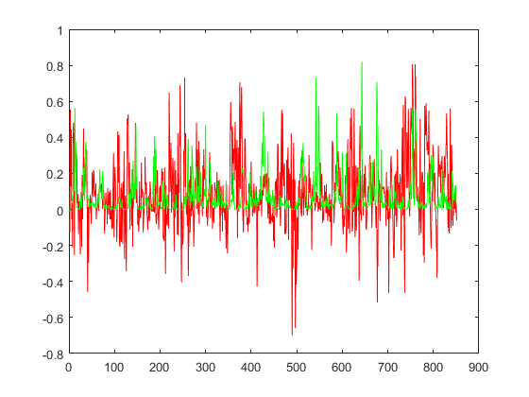

--------------- **RAINFALL NORMALISED | GAUSSIAN KERNEL FUNCTION**  ---------------

|  |  |  |  |
| --- | --- | --- | --- |
| **INPUT** | | **MODEL** | |
| TRAINING SET | CONCATENATED INSTANCES FROM 1 TO 3904, FROM 2 TO 3905 AND FROM 3 TO 3906 OF EXTMAT2 | SUPPORT VECTOR MACHINE REGRESSION MODEL | |
| TARGET FOR THE TRAINING SET | INSTANCES FROM 4 TO 3907 OF rain_mum_1969_2007_1grid_norm | TRAINING | * mdl8_2 = fitrsvm(T4_2,G,’KernelFunction’,’gaussian’) * Trained using the predictor values in the matrix T4_2 and the response values in the vector G * T4_2[3904 x 3030]=instances from 1 to 3904, from 2 to 3905 and from 3 to 3906 of EXTMAT2 * G[3904 x 1]=instances from 4 to 3907 of rain_mum_1969_2007_1grid_norm |
| TEST SET | CONCATENATED INSTANCES FROM 3905 TO 4755, FROM 3906 TO 4756 AND FROM 3907 TO 4757 OF EXTMAT2 | PREDICTING | * yfit8_2 = predict(mdl8_2,Tp4_2) * Tp4_2 is the Test set * Tp4_2[851 x 3030]= instances from 3905 to 4755, from 3906 to 4756 and from 3907 to 4757 of EXTMAT2 |
| TARGET FOR THE TEST SET | INSTANCES FROM 3908 TO 4758 OF rain_mum_1969_2007_1grid_norm | TESTING | * err8_2= immse(yfit8_2,Gp) = **0.0122** * err8_2 is the Mean Square Error * yfit8_2[851 x 1]=predicted values on the Test set * Gp[851 x 1]=instances from 3908 to 4758 of rain_mum_1969_2007_1grid_norm |

PLOTTING : plot(yfit8_2,'r')

hold on;

plot(Gp,'g')

